

Search

David Murphy

04 August [Development](https://messapps.com/tag/development/)

**Finding your iOS Device’s UDID Via iTunes**

Each iOS device has a UDID, or a **Unique Device Identifier** ­ a sequence of 40 characters that's unique to each individual device.

Think of a UDID as your phone’s social security number: It's used by developers to connect particular devices to a specific iOS Developer Account, allowing particular individuals to access and test exclusive content.

Developers typically perform a closed beta before a major release to test the functionality iOS apps on different devices. UDID's allow devs to assess how their apps perform on particular devices in a way that’s fast, painless and secure. Before starting a beta of your own, you’ll first need to create an **Apple Developer's Account:** [**Click here for a quick how­to!**](https://messapps.com/academy/creating-first-ios-developer-account-2/)

To find your UDID, open up the latest version of [**iTunes**](http://www.apple.com/itunes/) and **connect your iOS device to your computer.**

**Select your iOS device** by clicking the device's image located at the upper­left corner of iTunes’s UI

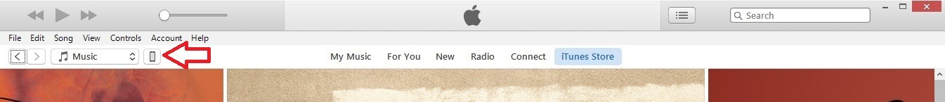

On the next screen, a window should appear listing your phone’s **Capacity**,**Phone Number**, and **Serial Number**

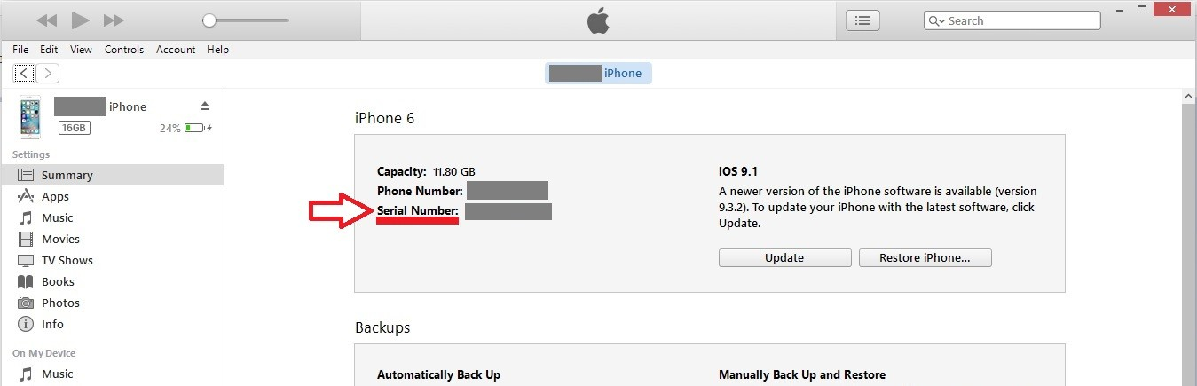

By clicking on **Serial Number** once, the prompt should change to display your **UDID**

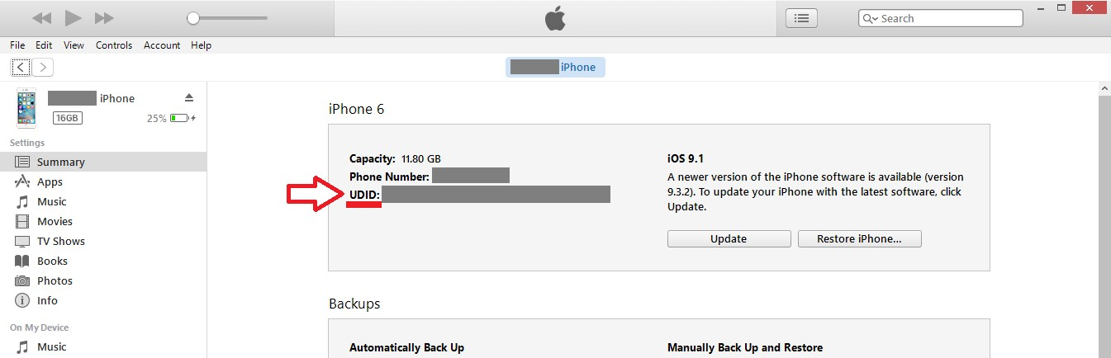



You might also like this articles

Dominick Wojtas

Dominick Wojtas

Since your UDID will never change (on its own), copy and paste it elsewhere for quick and easy access later in the future!

0

26 September



# [Identifying Your Target Market](https://messapps.com/academy/articles/identifying-target-market/)

In Putting Your Idea on Paper we talked about refining and explicating your idea. Now that you have a better idea of your app, its strengths, and its features, it is time to think about your target market. This is important to do before you finish honing your idea, because your conclusions about who you target might affect the way you develop the app and have implications for the features you include or exclude in it.

0

13 October

# [Does My Company Need a Mobile App or a Mobile Website?](https://messapps.com/academy/articles/company-need-mobile-app-mobile-website/)

Mobile apps and mobile websites both benefit the modern marketer. In previous years, however, experts have debated the impact of selecting one over another. Marketing strategies take time to fully form, and not every business impacts customers through multiple channels.

0